Part 2:

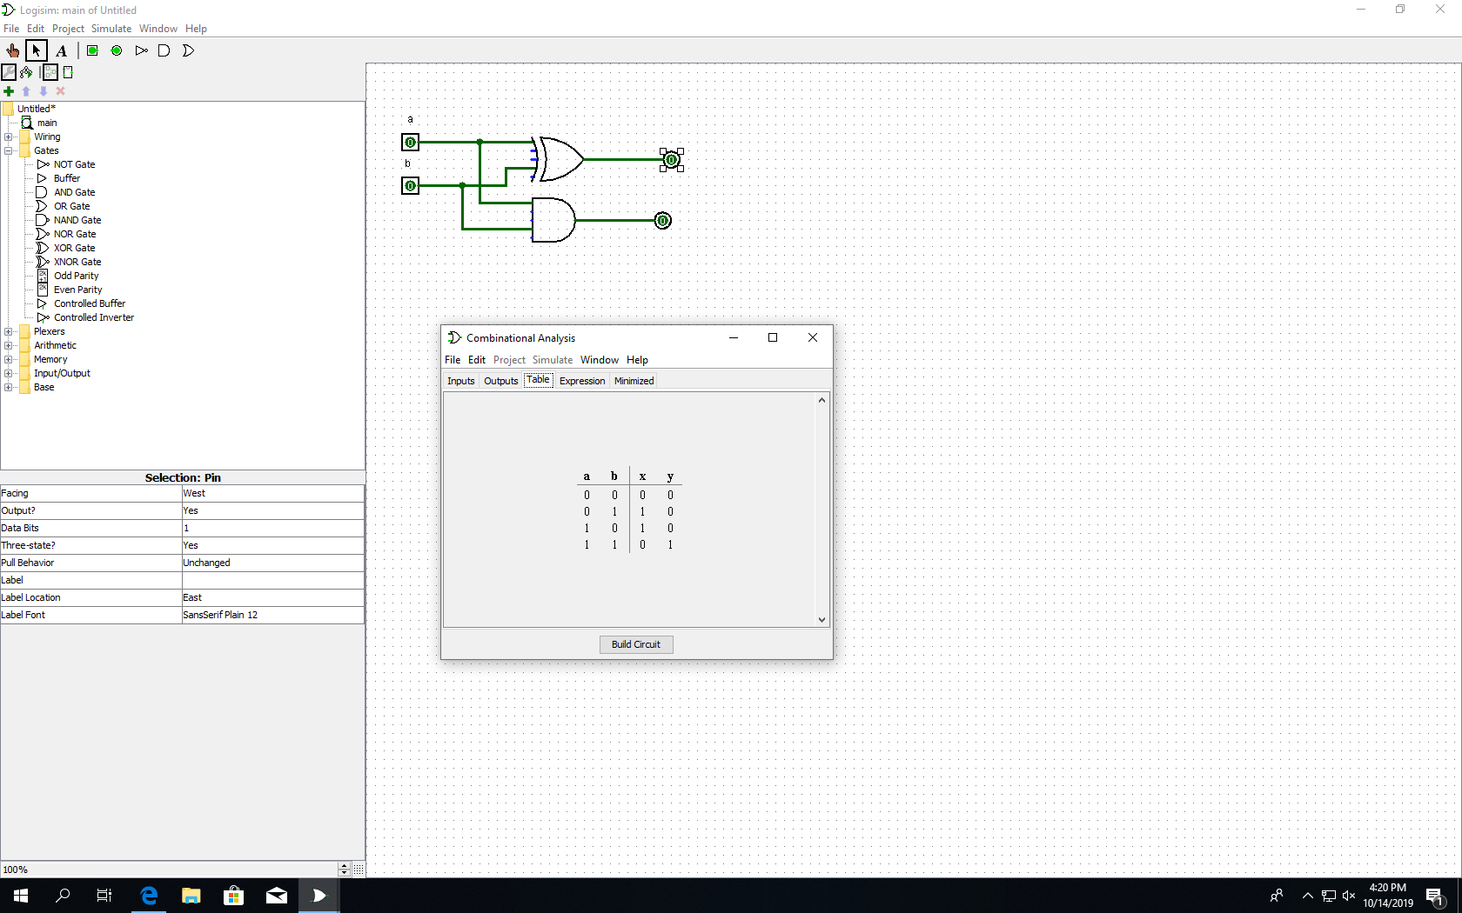

Part 2 A):

